# Method 1 - Logistic Regression

When the predicted outcome of the model is categorcial logistic regression can be used. Since we are trying to predict the game results which 1 or 0 the logistic regression model fits best to our problem therefore we decided to use this method. We are trying to learn directly $P(Y|X)$ with assuming $P(Y|X)$ takes functional form. In other words, sigmoid function applied to a linear function of the data. The sigmoid funtion is shown in the following figure.

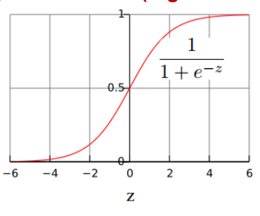

Figure 1 – Logistic Function (Sigmoid Function)

The calculated probability is the hypothesis's output. When given an input X, this is utilized to determine how certain a predicted value can be the actual value. The probabilities are calculated by the fallowing formulas.

$P\left(Y=1 | X\right)=\frac{1}{1+e^{(w_{0}\sum_{i=1}^{n}{w_{i}X_{i}})}}$ (1)

$P\left(Y=0 | X\right)=\frac{e^{(w_{0}\sum_{i=1}^{n}{w_{i}X_{i}})}}{1+e^{(w_{0}\sum_{i=1}^{n}{w_{i}X_{i}})}}$ (2)

The predicted value for Y wil be equal to the output of the class with highest $P(Y|X)$.

$1<\frac{P\left(Y=0 | X\right)}{P\left(Y=1 | X\right)}$ (3)

$1<e^{(w_{0}\sum_{i=1}^{n}{w_{i}X_{i}})}$ (4)

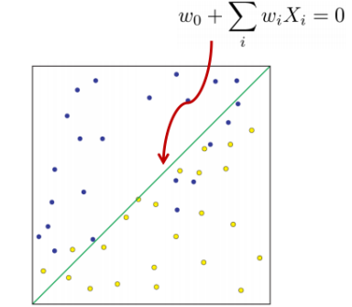

Figure 2 – Linear Decision Boundry

In order to learn parameters $w_{0}, w_{1}, ……, w_{n}$ we are going to use maximum conditional likelihood estimator which is the following where training data is ${\left\{X^{(j)},Y^{(j)}\right\}}_{j=1}^{n}$

${\hat{w}}_{MCLE}=arg\max_{w}{\prod_{j=1}^{n}{P\left(Y^{(j)} | X^{(j)},w\right)}}$ (5)

Since conditional likelihood for Logistic Regression is concave we are going to use Gredient Ascent to optimize parameters.

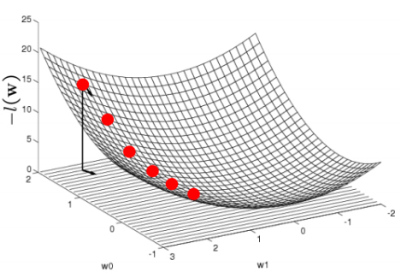

Figure 3 – Gradient Ascent

Gradient:

$∇_{w}l\left(w\right)=\left[\frac{∂l(w)}{∂w_{0}},……,\frac{∂l(w)}{∂w_{n}}\right]$ (6)

Uptade rule (where n is learning rate):

$∆w=n∇_{w}l\left(w\right)$ (7)

# Method 2 – SVM

We are going to use SVM classifier for linearly seperable classes for problem. An SVM training algorithm creates a model that assigns new examples to one of two categories, making it a non-probabilistic binary linear classifier, given a series of training examples, each marked as belonging to one of two categories[wikipedia]. The key idea behind SVM is hyperplane that maximizes the margin will have better generalization. For a linearly seperable data SVM can better be understand from the following figure.

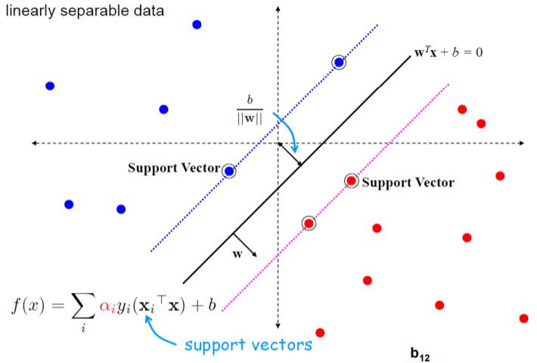

Figure 3- Support Vector Machine

Since $w^{T}x+b=0$ and ${c(w}^{T}x+b)=0$ define the same plane we can decide the normnalization of w such that $w^{T}x_{+}+b= +1$ and $w^{T}x_{-}+b= -1$ for the positive and negative support vectros respectively.

The margin can be found by

$$\frac{w}{\left\|w\right\|}*\left(x_{+}-x_{-}\right)=\frac{w^{T}\left(x_{+}-x_{-}\right)}{\left\|w\right\|}=\frac{2}{\left\|w\right\|}$$

The geometric representation of SVM is the folowing

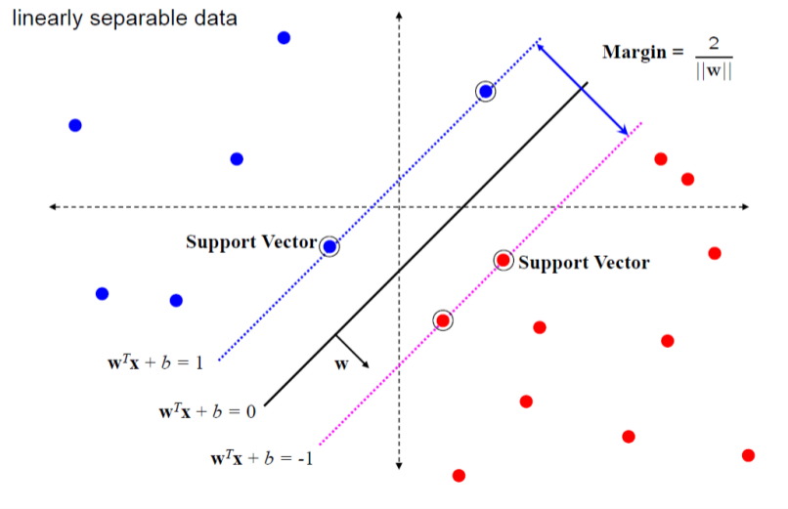

Figure 4 – Geometric representation of SVM

Then learning SVM can be formulated as optimization problem where it is a quadratic optimization problem subject to linear constraints and ther exist a uniqe minimum.

$$\min_{w}{{\left\|w\right\|}^{2}}subject to y_{i}\left(w^{T}x_{i}+b \right)≥1 for i=1……N$$

# Method 3 – kNN Classifier

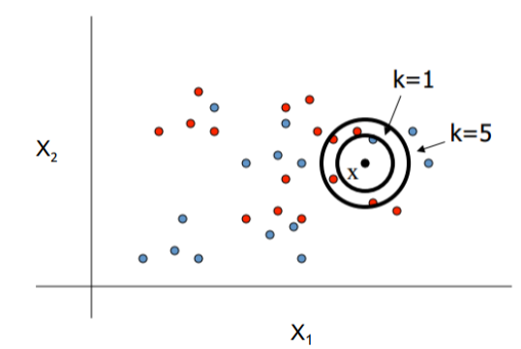In the kNN classfier we are assuming all instances are points in n-dimensional space and we are required to use a distance measure to determide the “closeness” of instances. Although there are different types of distance metrics such as Minkowski distance, Manhattan distance, Cosine distance, Jaccard distance; Euclidean distance fits bets for our case. Given all that NBA performance measurements are numeric and have the same units, we can directly use Euclidean distance defined as the square root of the sum of the squared differences between the two arrays of number. In our case each row of the future set can be considered as an array of number. Finally, we are classifying an instance by finding its nearest neighbors and picking the most popular class among the neighbors.

Figure 5 – kNN Classifier